**Yuriy Tumakha**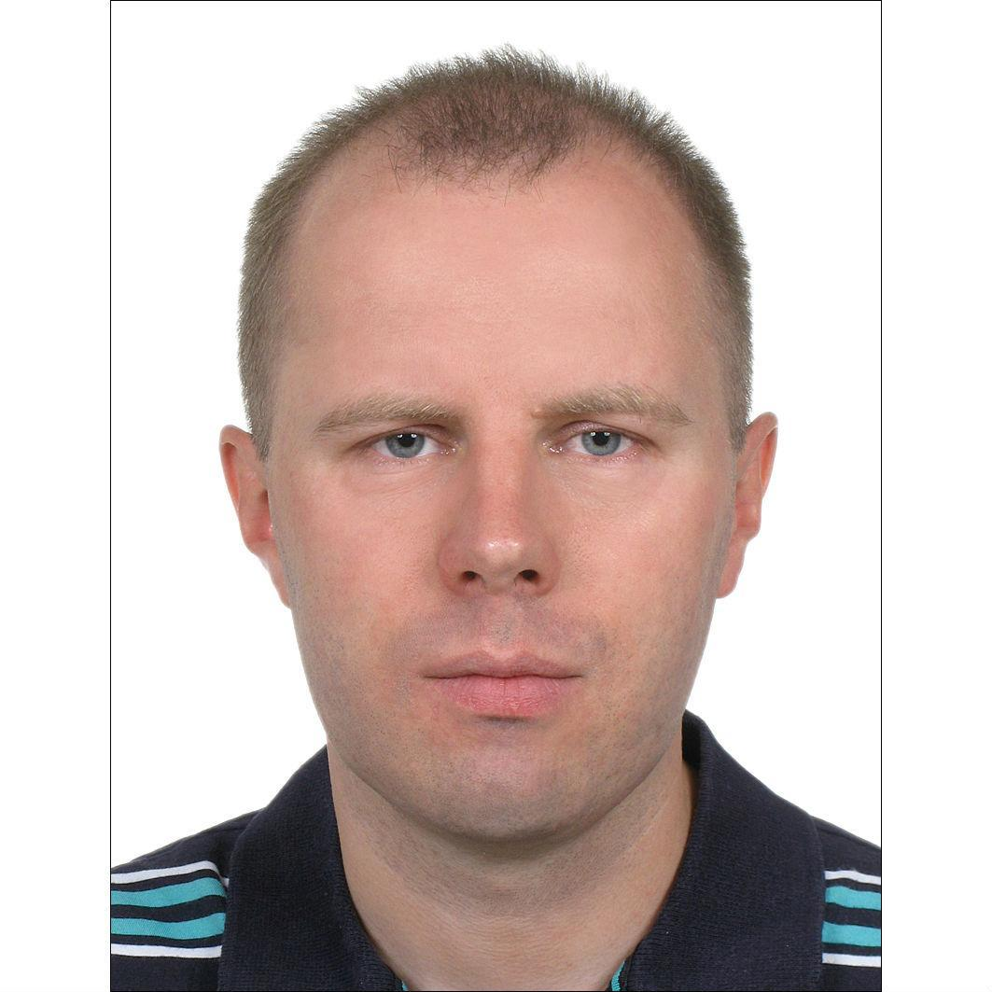

**Phone: +447476145541 E-mail:** [**yuriy@tumakha.uk**](mailto:yuriy@tumakha.uk)

**Address: London, UK**

[**https://tumakha.uk**](https://tumakha.uk)

[**https://linkedin.com/in/tumakha**](https://linkedin.com/in/tumakha)

**PERSONAL SUMMARY**

Senior Developer with 20 years of experience in Java development and 6 years in Scala with strong problem-solving skills. A team player who contributes ideas and takes on challenges.

**KEY SKILLS AND COMPETENCIES**

* Scala Back-End: Scala, Akka (Cluster, Streams, Http), Apache Spark, Play Framework, Slick, SBT
* Java Back-End: Java, Spring Boot/Data/MVC/Cloud, JPA, Akka Streams, Kafka, Gradle, Maven
* Databases: MySQL, Oracle, MongoDB, Cassandra
* Testing: JUnit, DbUnit, JsonUnit, XMLUnit, Mockito, TestNG, REST Assured, Selenium

**WORK EXPERIENCE**

**Scala Developer - HMRC**September 2021 - now, London, UK  
Valuation Office Agency microservices support and development.  
Scala, Cats, Play Framework, Akka, MongoDB

**Senior Java/Scala Developer - iPlato Healthcare**September 2020 - September 2021, London, UK  
<https://mygp.com> back-end microservices.

AWS, Microservices, Docker, Scala, Java 11, Akka, Akka Http, elastic4s, DynamoDB, Debezium, Spring Boot/Cloud, Consul, Elasticsearch, Kafka, RabbitMQ, MySQL

**Senior Software Engineer - Asset Control**August 2019 - February 2020, London, UK

Asset management software.  
Scala, Java, AWS, Kubernetes, Docker, Hazelcast, Apache Spark, Akka, Play, Kafka, Cassandra

**Senior Java Software Engineer - Tantalum Corporation**April 2018 - June 2019, London, UK

Telematics Platform for tracking vehicles.

Java 8, Microservices, AWS, Spring Boot, Spring Cloud, Consul, Marathon, Kafka, Cassandra  
Implemented by me the following microservices:

**api-subscriptions** - Asynchronous integration with company ATT to synchronize users profiles and subscriptions

**svc-ecosystems-gateway** - Integration with Harman endpoints to get device status/change Wi-Fi settings

**svc-trip-batch** - Converting trip telematics data to CSV format to calculate driving score by Octo Telematics

**api-device-administration** - REST API to get device data, associate with user, enable Wi-Fi, cancel registration

**api-device-status** - REST API to get current comprehensive device status and status changes history

**api-admin-router** - Entry point for all REST APIs used by Support Portal

**cmd-sender** - Application to send in free form messages and push notifications to users

**sls-monitoring** - Microservices monitoring Lambda deployed by Serverless framework <https://serverless.com>

**Scala Developer (Contract) - EileanTech Ltd**July 2017 - Mar 2018, London, UK

Implemented Archipelago framework integration components for Database, JMS, HTTP, JSON, XML and sort/aggregate/transform components.

Scala, Akka, Slick, scalatest, SBT, Git, JMS, JSON, XML

**Software Engineer - 10x Banking**

February 2017 - June 2017, London, UK

Banking platform microservices.

Java 8, Maven, AWS, Amazon SQS, DynamoDB, Activiti workflow

**Senior Java/Scala Developer - Freelance**

February 2014 - January 2017

Dashboard to monitor and control Wind Turbines. (Java 8, Spring Boot, SOAP, AngularJS)

Yellowfin BI plugins views for REST APIs (Java 8, yellowfinbi-7.2, retrofit-2, okhttp-3, gson)

Java 8, Camel, Spring, JPA, Spring MVC, Scala, Akka, SBT, Play framework, JIRA plugin

**Senior Java Developer - Epam Systems**

September 2013 - January 2014, Kyiv, Ukraine

Implemented new features for bank trades processing. Improved test coverage.

IBM Java 5, Maven, Spring, Hibernate, JMS, XML, XSLT, JUnit, TDD, Agile

**Senior Java Developer - Ciklum**

January 2012 - May 2013, Kyiv, Ukraine

Implemented from scratch Players Campaign management solution.

Java 7, Oracle, Hibernate, Spring, JPA, REST, ActiveMQ, Tapestry, TDD, Agile

**Senior Java Developer - Thomson Reuters**

December 2007 - January 2012, Kyiv, Ukraine

Implemented new features for Thomson Reuters commercial portals and internal services.

Java 6-7, Hibernate, JPA, Spring, Web Services, Maven, JUnit, TDD, Agile

**Senior Java Developer - Softline**

December 2006 - December 2007, Kyiv, Ukraine

Developed web-application for managing profiles, import/export XML by HTTPS, FTP.

Java 6, J2EE, MULE ESB, Web Services, JUnit, Cactus, Ant

**Java Developer - Luxoft**

February 2006 - December 2006, Kyiv, Ukraine

Developed web-application for internal use on ChNPP. It is designed to work with an electronic archive of documents, and integration with the monitoring system of object "Shelter".

Java 5, J2EE, Servlets, JSP, Struts, Oracle PL/SQL, Oracle CM SDK

**PHP Developer - MitriDAT**

March 2005 - December 2005, Kyiv, Ukraine

<https://smsportal.media24.no> - SMS Portal for bulk message sending, postponed sending, websites integration.

PHP, DHTML, MySQL, XML, XSL

**EDUCATION**

1997 - 2002: Ternopil Ivan Puluj National Technical University, Ukraine

Lightbend Akka Cluster - Sharding (Scala) (July 2020)

<https://www.youracclaim.com/users/yuriy-tumakha>

Big Data Analysis with Scala and Spark (April 2017, License KSUENLP7B886)

<https://www.coursera.org/account/accomplishments/verify/KSUENLP7B886>